

CIS C290

M03 Lab Assignment: Descriptive Statistics

Part 1. Load the data_science_salaries.csv file into the Python environment and include a screenshot of the output.
# load data_science_salaries.csv
import pandas as pd

# load the dataframe.
This is the file path.
df = pd.read_csv('/content/data_science_salaries.csv')

# print information
df.info()
df.head()

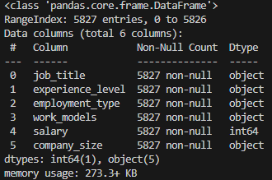
NOTE: You need to find the file path to your csv file (CoLab Video)

Part 2. Calculate counts of experience level and include a screenshot of the output.
# group data by 'experience_level’ and count occurrences
experience_level_counts = df.groupby('experience_level')['experience_level'].count()
print("Experience Level Counts:\n", experience_level_counts)

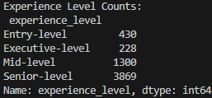

Part 3. Calculate descriptive statistics for salary and include a screenshot of the output.
# descriptive statistics for ‘salary’
print(df['salary'].describe())

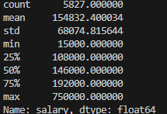

Part 4. Calculate the average salary by experience level and include a screenshot of the output.
# group data by ‘experience_level’ and calculate the average ‘salary’ for each group
average_salary_by_experience = df.groupby('experience_level')['salary'].mean()

# print the result
average_salary_by_experience

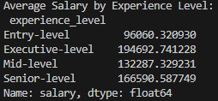

Part 5. Create a formatted table by employment types and company size.
# create a formatted table based on counts of 'employment_type' and 'company_size'

# group data by 'employment_type' and 'company_size', then count occurrences
grouped_data = df.groupby(['employment_type', 'company_size']).size().unstack(fill_value=0)

# display the formatted table
print("Counts of Employment Type and Company Size:\n")
grouped_data

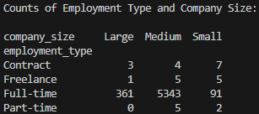

Part 6. Create a bar chart by experience level counts.
# create a bar chart based on the counts of 'experience_level'
import matplotlib.pyplot as plt

# create the bar chart
plt.figure(figsize=(10, 6))
plt.bar(experience_level_counts.index, experience_level_counts.values)
plt.xlabel("Experience Level")
plt.ylabel("Number of Employees")
plt.title("Distribution of Experience Levels")
plt.show()

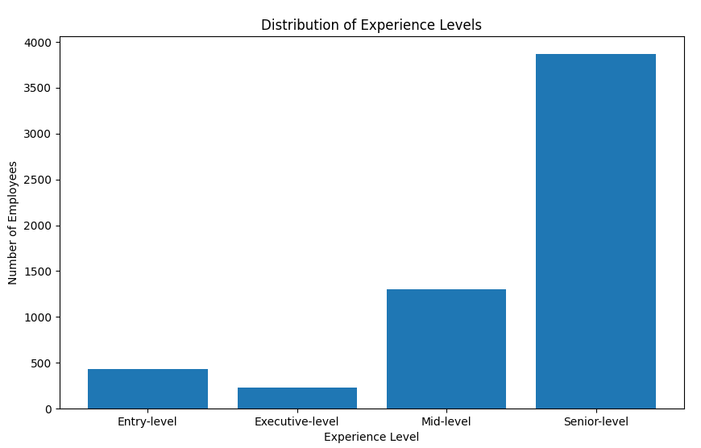

Part 7. Create a pie chart by employment type counts.
# create a pie chart based on the counts of 'employment_type'

# create the pie chart
plt.figure(figsize=(8, 8))
plt.pie(experience_level_counts.values, labels=experience_level_counts.index, autopct='%1.1f%%', startangle=90)
plt.title("Distribution of Experience Levels")
plt.axis('equal') # Equal aspect ratio ensures that pie is drawn as a circle.
plt.show()

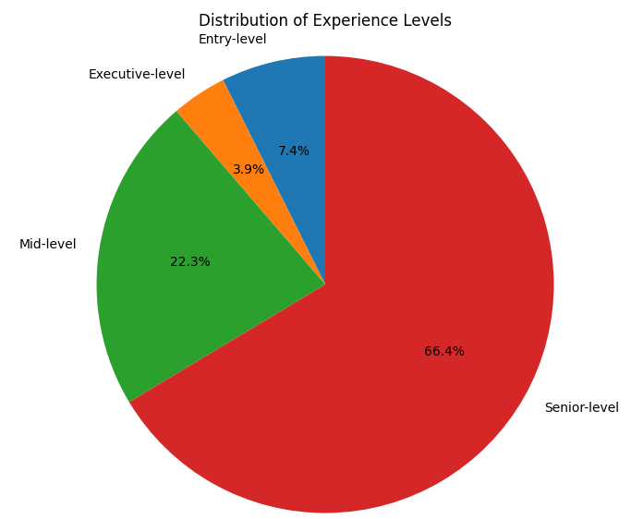

Part 8. In a minimum of 3 sentences, describe your experience with the assignment. Indicate which resources you used.

During this assignment, I had some issues with the file path not rendering correctly and some of the libraries not installed properly. For the file path, I fixed by changing the directory of the csv file to the same folder as the python file. Whereas the libraries, I used copilot to ensure that I have the dependencies installed properly. Overall, this assignment was smooth with the programming and reading.

